 | 6.1 Metals and non-metals
Task 2 |  | Metals and non-metals (version 2)

Correct the following.
Metals are shiny, poor conductors of heat and electricity, and can be bent and shaped and are usually a gas at room temperature. Non-metals are dull, poor conductors of electricity and heat, brittle, and usually solid or gas at room temperature. However, chlorine is a non-metal that is a liquid at room temperature and copper is a metal that is liquid at room temperature.
Metals and non-metals can react with oxygen in the air to form carbonates which are either acids or bases. Some metals react with alkalis to form a substance called a salt. An example of this is when zinc oxide is reacted with hydrochloric acid to form zinc sulfate. The zinc sulfate is a salt. During the reaction, oxygen gas is given off. We can test for this gas using the pop test.
We can summarise the reaction between the metal and acid using this equation:-
acid + metal → salt + water

 | 6.2 Acids and alkalis
Task 1 |  | True or false?

Read the statements below and for every false statement write a corrected version in the space below.

Statement | True or  False | Corrected statement
Everyday acids can be found in soap, hair shampoo, and even toothpaste.
All acids have the element hydrogen in common.
Hydrochloric acid contains the elements of hydrogen, oxygen, and chlorine.
All alkalis are harmless.
The pH of a solution depends on how much water is mixed with the acid.
Strong acids have a lower pH than weak acids.
Blue litmus paper turns red in acid.
Red litmus paper turns blue in an acid.
Most flowers, fruit, and plant parts that are red, blue, or purple can be used as indicators.
We use Universal indicator to know how strong or weak an acid or alkali is.

 | 6.3 Chemical energy
Task 1 |  | Definitions

Match the word with the definition. Learn the definitions.
chemical bond |  | One in which energy is given out, usually as heat or light.
catalysts |  | A change in which a new substance is formed.
exothermic reaction |  | Substances formed in a chemical reaction, shown after the reaction arrow in an equation.
endothermic reaction |  | The force that holds atoms together in molecules.
chemical reaction |  | One in which energy is taken in, usually as heat.
reactants |  | Substances that speed up chemical reactions but are unchanged at the end.
products |  | Substances that react together, shown before the arrow in an equation.

 | 6.3 Chemical energy
Task 1 |  | Sheet A - hand warmers

Use the internet and other resources to complete the following tasks:
Hand warmers
- Describe what chemical hand warmers are and how they are used.
- Explain how the hand warmers work.
- Is the reaction endothermic or exothermic? How can you tell?
- Draw a reaction profile for this reaction. Add labels for the product and reactants to the reaction profile.
- What other uses can you find for this type of reaction?

Task 2 | Sheet B – cold packs

Use the internet and other resources to complete the following tasks.
Chemical cold packs
- Describe what chemical cold packs are and how they are be used.
- Explain how chemical cold packs work
- Is the reaction endothermic or exothermic? How can you tell?
- Draw a reaction profile for this reaction. Add labels for the product and reactants to the reaction profile.
- What other uses can you find for this type of reaction?

 | 6.4 Types of reaction
Task 1 |  | Reactions

Highlight the correct answers for each question. Some questions may have more than one answer.
Which of the following are metals?
mercury | iron | bromine | oxygen

Which of the following are non-metals?
bromine | sodium | fluorine | calcium
Combustion is a reaction that needs …
carbon dioxide | air | oxygen | nitrogen
During combustion, energy is transferred to the surroundings as and
heat | fire | light | chemical energy
Thermal is a reaction where a single reactant is broken down by heat.
burning | decay | boiling | decomposition
During a chemical reaction, atoms and molecules are rearranged but the ……. is always conserved.
mass | colour | state | reactants
Reactants are substances that …
are produced in a chemical reaction. | are needed for a chemical reaction. | should never be reacted. | are safe to react.
Mercury oxide is broken down using only heat. Which two products are formed?
mercury | carbon dioxide | oxide | oxygen

Extension
- Write a word equation for this investigation. Copper and sulfur are heated in a roaring flame for two minutes. When the student removed the boiling tube from the flame she noticed that the copper had a bluish coating surface.
- 32 g of sulfur is burned with iron to produce 88 g of iron sulfide. Calculate how much iron was involved in the reaction.
- 16 g of methane was burned with 64 g of oxygen during a combustion reaction. 44 g of carbon dioxide was produced. Calculate the amount of water produced in the reaction, using the idea of conservation of mass.

ANSWERS
 | 6.1 Metals and non-metals
Task 2 |  | Metals and non-metals

There are two versions of the student sheet. The first is more challenging than the second. The corrected text is on slides 7–8 of the PowerPoint. As an alternative ask several students to read out their answers.

Answers
Metals are shiny, good conductors of heat and electricity, can be bent and shaped, and are usually solid at room temperature. Non-metals are dull, poor conductors of electricity and heat, brittle, and usually solid or gas at room temperature. However, bromine is a non-metal that is a liquid at room temperature and mercury is a metal that is liquid at room temperature.
Metals and non-metals can react with oxygen in the air to form oxides which are either acids or bases. Some metals react with acids to form a substance called a salt. An example of this is when zinc is reacted with sulfuric acid to form zinc sulfate. The zinc sulfate is a salt. During the reaction, hydrogen gas is given off. We can test for this gas using the pop test.
We can summarise the reaction between the metal and acid using this equation:
acid + metal → salt + hydrogen

 | 6.2 Acids and alkalis
Task 1 |  | True or false?

Suggested answers
The corrected statements are on slide nine of the PowerPoint.
Statement | True or False | Corrected Statement
Everyday acids can be found in soap, hair shampoo, and even toothpaste. | F | Everyday alkalis can be found in …
All acids have the element hydrogen in common. | T
Hydrochloric acid contains the elements hydrogen, oxygen, and chlorine. | F | … contains the elements hydrogen and chlorine.
All alkalis are harmless. | F | Not all alkalis are harmless.
The pH of a solution depends on how much water is mixed with the acid. | F | The pH of a solution depends on the strength of an acid.  The concentration of a solution …
Strong acids have a lower pH than weak acids. | T
Blue litmus paper turns red in acid. | T
Red litmus paper turns blue in an acid. | F | Red litmus paper turns blue in an alkali.
Most flowers, fruit, and plant parts that are red, blue, or purple can be used as an indicator. | T
We use Universal indicator to know how strong or weak an acid or alkali is. | T

 | 6.3 Chemical energy
Task 1 |  | Definitions

chemical bond | Force that holds atoms together in molecules.
catalysts | Substances that speed up chemical reactions but are unchanged at the end.
exothermic reaction | One in which energy is given out, usually as heat or light.
endothermic reaction | One in which energy is taken in, usually as heat.
chemical reaction | A change in which a new substance is formed.
reactants | Substances that react together, shown before the arrow in an equation.
products | Substances formed in a chemical reaction, shown after the reaction arrow in an equation.

 | 6.3 Chemical energy
Task 2 |  | Hand warmers and cold packs

Suggested answers
Sheet A
- Hand warmers are often sold to fit inside of gloves or at outdoor events.
- A chemical reaction is started that causes energy to be released in the form of heat.
- Iron powder is reacted with oxygen forming rust Fe₂O₃ which releases heat (there are other examples).
- The reaction is exothermic because the hand warmer heats up.

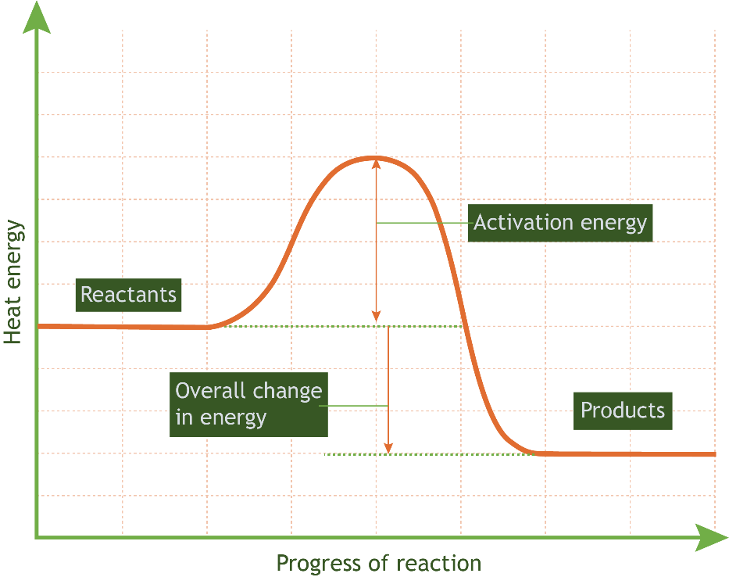

Sheet B
- Cold packs are used for sports injuries.
- A chemical reaction is started when ammonium nitrate and water react, causing energy to be absorbed from the surroundings.
- The reaction is endothermic because the reaction causes the surroundings to cool down.

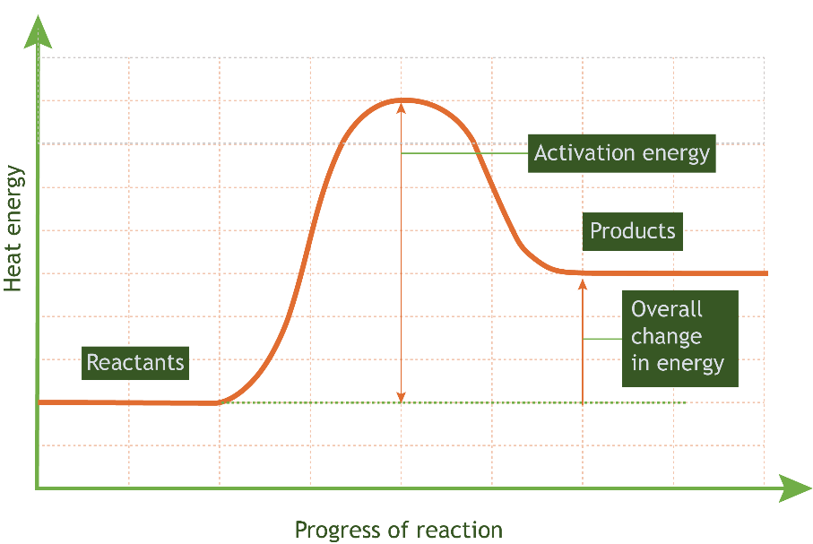

Exothermic | Both | Endothermic
Releases energy to the surroundings. | Need activation energy | Absorbs energy from the surroundings.
The energy released is higher than the activation energy. | Involve a chemical reaction where reactant bonds are broken, and product bonds are made | The energy released is lower than the activation energy.
 | Graphs show energy changes over time

 | 6.4 Types of reaction
Task 1 |  | Reactions
Assessment and answers
Students can mark their answers.
Which of the following are metals?
mercury | iron | bromine | oxygen

Which of the following are non-metals?
bromine | sodium | fluorine | calcium

Combustion is a reaction that needs …
carbon dioxide | air | oxygen | nitrogen

During combustion, energy is transferred to the surroundings as and .
heat | fire | light | chemical energy

Thermal is a reaction where a single reactant is broken down by heat.
burning | decay | boiling | decomposition

During chemical reactions, atoms and molecules are rearranged but the is always conserved.
mass | colour | state | reactants

Reactants are substances that …
are produced in a chemical reaction. | are needed for a chemical reaction to take place. | should never be reacted. | are safe to react.

Mercury oxide is broken down using only heat. Which two products are formed?
mercury | carbon dioxide | oxide | oxygen

Extension
- Write the word equation for this investigation. Copper and sulfur are heated in a roaring flame for two minutes. When the student removed the boiling tube from the flame she noticed that the copper had a bluish coating surface.
copper + sulfur → copper sulfide

- 32 g of sulfur is burned with iron to produce 88 g of iron sulfide. Calculate how much iron was involved in the reaction.
32 g + mass of iron → 88 g
88 g - 32 = 56 g
mass of iron = 56 g

- 16 g of methane was burned with 64 g of oxygen during a combustion reaction. 44 g of carbon dioxide was produced. Calculate the amount of water produced in the reaction, using the idea of conservation of mass.
methane + oxygen → carbon dioxide + water
16 g + 64 g = 44 g + mass of water
80 g = 44 + mass of water
80 - 44 = 36
mass of water = 36 g

