Code Resources Pack
Introduction:
Codes are a great way to show you some real-life applications of mathematics (and possible career paths for mathematicians), as well as being a fun activity.
In this pack are 2 ideas for session plans to give an idea of what can be done. The following link gives you access to all hyperlinks, downloadable content and the video content on http://ibmathsresources.com/2013/05/31/cracking-codes-lesson/ - so this will be useful to look at. Cryptography Super Sleuth department is linked there for example – and is another resource which is well worth downloading and looking through if you find you enjoy this!
At the end of the pack, there are two murder mystery set ups. The idea is for you to edit these and play them together!
There is also an online code challenge http://ibmathsresources.com/code-challenge/ aimed specifically at Yr 7/8 students. There are 5 codes to crack – once the first one is broken, it gives a password which allows the students to access the next page. There is a leaderboard which is updated with all those who successfully complete it!
Year 7- complete up to task 4 and have a look at the above-mentioned online code challenge
Year 8- complete up to task 7 and have a look at the above-mentioned online code challenge
Year 9- Complete whole pack
All can have a go at extension murder mystery activities
Contents:
- Session plan example
- Why study codes in maths?
- Caesar Shifts and Transposition Ciphers
- Vigenere Cipher resources
- ISBN code resources
- Credit Card code resources
- Enrich number puzzle
- NASA binary code resources
- Hidden sentence algebra
- NEW – the maths behind the internet, how RSA encryption keeps data safe (hard)
- Code Challenge lessons I, II III
- Murder in the Maths Department 1
- Murder in the Maths Department 2
- Solutions (make sure to hide these away until you’ve done the tasks yourself!)
- Resources

Ways to break down the tasks…
Session 1:
Introduction: 5 minutes – Use a Morse Code Generator (http://www.glassgiant.com/geek/morse/) to play some (very slowed down) messages for you to decode. Discuss why this is was a good way to transmit data in the past.
Brainstorm: 5 minutes – Why are codes important? Who uses them? Why do mathematicians go into this career? Look at all data transmission – TVs, internet, mobile phones. Discuss the picture at the top of the page - this was transmitted from Mars – which is on average 225 million km from Earth (why on average?) So, how can we transmit data across such a huge distance?
Video: 10 minutes: Watch Marcus De Satouy video explaining codes (stop around 8.30): http://www.youtube.com/watch?v=ecZuVBhH_iY&feature=player_embedded
Worksheet: Between 30 mins and 50 minutes depending on ability and hints - Give out code challenge worksheet – Murder in the Maths Department. Working in groups of 2-3. Students will probably need direction – but try to limit this to a minimum to encourage problem solving. (First students to finish should create their own coded messages for each other).
Session 2:
Binary Codes Introduction: 5 minutes - Can we see the link between binary codes and Morse codes? Why are binary strings good for sending data? Link back to Mars picture. Talk about SETI – what is SETI (Search for Extra-Terrestrial Intelligence), what do they do? (Scan sky looking for non-random data strings)
Binary Code Worksheet: 25 minutes - Students need to convert the binary string codes into pictures.
Extension material: 25 minutes – Handout Vignette Cipher, ISBN codes and Credit Card Codes for top ability students

Why study codes in maths?
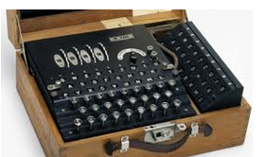

There is a long history of mathematicians being used in code making and code breaking - the most famous is probably the Bletchley Park code breakers, where some of the most brilliant mathematicians in the country such as Alan Turing worked in secret to crack the German WWII Enigma code. The picture above shows an Enigma machine. The code was so complicated that the Germans were confident that it was unbreakable, however the men and women at Bletchley Park were able to crack it using incredible ingenuity. This meant that the allies were able to intercept and understand German communications – a huge breakthrough in the war.
Codes now play an integral part in all our lives - from the ISBN codes on the back of every book you buy, to the algorithm that checks if the credit card you've entered is genuine, from the encrypted data sent via the internet to the content you watch on digital TV.
Mathematicians are employed throughout a wide range of industries that send and transmit data – in particular the telecommunications industry and internet companies. Their challenge is to condense the data that needs to be sent to as small a file as possible – whilst also allowing potential errors in communication to be noticed by the receiver. As coding now goes hand in hand with computing skills, good mathematicians are highly sought after for computing courses at top universities around the world.
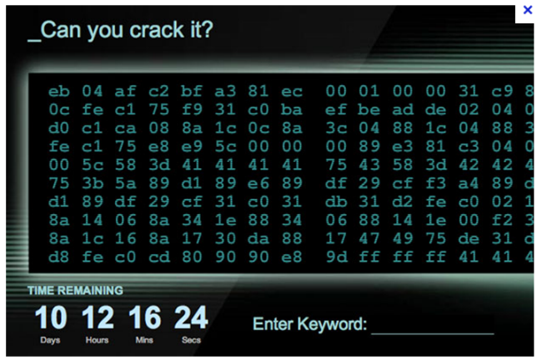
There is also still a need for the traditional code makers and code breakers. Highly sensitive data needs to be encrypted to prevent it from falling into the wrong hands – whilst our spies need to be able to crack the codes of other countries. Indeed, GCHQ (the British Intelligence Agency responsible for digital communications) last year recruited new employees by posting a code online. Crack the code and you secured yourself an interview.
Therefore codes and coding theory represents a varied and interesting career path for good mathematicians. Get cracking!
Caesar Shifts
The Caesar Shift is one of the simplest codes we come across in cryptography. It is a substitution code, which means that each letter is replaced with another one. The code is named after the Roman Emperor Julius Caesar who use this method to send military messages to his army.
To encrypt or decrypt a Caesar shift we first list the alphabet, and then for a Caesar shift of three, we move every letter of the alphabet 3 places:
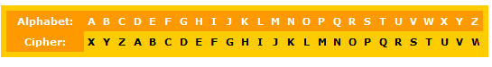
Here we would decode A as X, B as Y etc. So the message KHOOR translates to HELLO.
Caesar shift codes can be easily broken by conducting simple frequency analysis. If you count the frequency of each of the letters in the code, you can then compare these frequencies with how often they appear in English.
Looking at the frequencies we can see that:
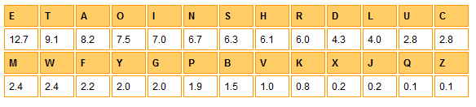
So, in a long message we would expect the most frequent code letter to correspond to E. That would be enough to crack the code. If that doesn’t work, try T or A etc. Try and decode these 2 messages:
- ZLKDOXQRIXQFLKP VLR EXSB ZOXZHBA QEB ZXBPXO PEFCQ ZLAB
- DOHA PZ AOL MPMAO AYPHUNBSHY UBTILY

Transposition Ciphers
Transposition Ciphers are based on a simple idea, but are more difficult to crack that codes like the Caesar shift. A transposition means that the letters of the code are simply rearranged into a different order.
For example, ICBKAOREMDERAEAA, can be rearranged into rows of length 4 to give:
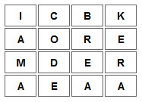
The message is then read from down the columns – I am a codebreaker.
Try and solve:
- TIOICCBKTHSRFUORIEIAEFLDENSSMDITEAGT ( make 4 rows of length 9)
- WTFRUELEHQRHIOSADUITUEASUQRPSGSAD (make 3 rows of length 11)
Another transposition Cipher used by the Romans was called the Scytale. This involved putting a message on a strip of paper that could only be read when wrapped around a rod of a given length. An example is given below:
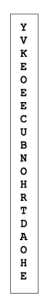
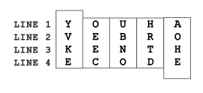

Vigenere encryption
The Vigenere encryption was the creation of the French diplomat, Blaise de Vigenere in the 1500s. It combines multiple different Caesar shifts – and so is much more difficult to crack using frequency analysis. First you need to choose a keyword. The example below uses the keyword “FIRST” - so it uses five different Caesar shifts, for F, I, R, S and T.
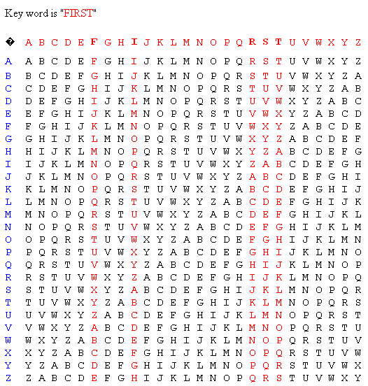
So for example with the codeword: BPFAG AMELX IKRDV ZTLK
With the first letter B, we look down the F column – and find B. Then look across to the far left column - this gives us W. Next we decode P by finding it in the I column, then looking across to the far left column – this will give H. Next we use the R column and look for F, and going to the far left column we get O. If we carry on with this method we get: WHO INVENTED CALCULUS?
- BPRLB XBYWM JVKZY NJFFT HKZFN RJVJ (also encrypted with keyword FIRST)
- TOPTS ZYLLU ANWZA ZAWHQ (encrypted with the keyword MATHS)

ISBN CODES
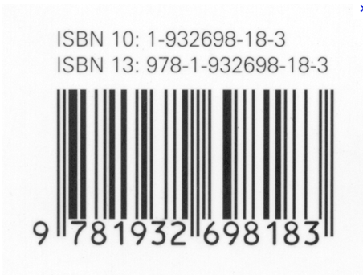
This is an ISBN code – it’s used on all books published worldwide. It’s a very powerful and clever code, because it has been designed so that if you enter the wrong ISBN code the computer will immediately know – so that you don’t end up with the wrong book. There is lots of information stored in this number. The first numbers tell you which country published it, the next the identity of the publisher, then the book reference.
Here is how it works:
Look at the 10 digit ISBN number. The first digit is 1 so do 1x1. The second digit is 9 so do 2x9. The third digit is 3 so do 3x3. We do this all the way until 10x3. We then add all the totals together. If we have a proper ISBN number then we can divide this final number by 11. If we have made a mistake we can’t. This is a very important branch of coding called error detection and error correction. We can use it to still interpret codes even if there have been errors made.
If we do this for the barcode above we should get 286. 286/11 = 26 so we have a genuine barcode.
Check whether the following are ISBNs
1) 0-13165332-6
2) 0-1392-4191-4
3) 07-028761-4
Challenge (hard!) :
The following ISBN code has a number missing, what is it?
1) 0-13-1?9139-9
CREDIT CARD CODES
Credit cards use a different algorithm – but one based on the same principle – that if someone enters a digit incorrectly the computer can immediately know that this credit card does not exist. This is obviously very important to prevent bank errors. The method is a little more complicated than for the ISBN code
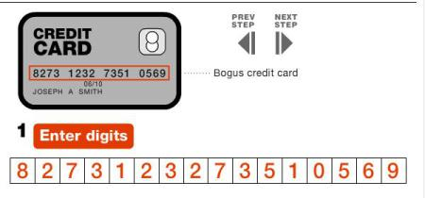
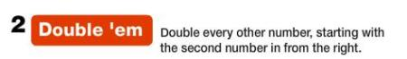
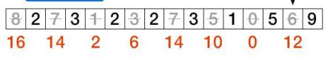
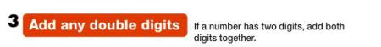
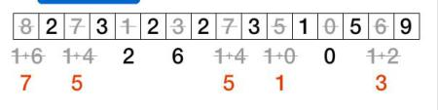
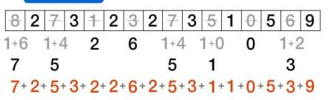
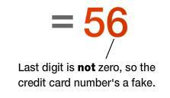
Try and use this algorithm to validate which of the following 3 numbers are genuine credit cards:
1) 5184 8204 5526 6425
2) 5184 8204 5526 6427
3) 5184 8204 5526 6424
Enrich number puzzle

There are 6 different numbers written in 5 different scripts. Can you find out which is which?

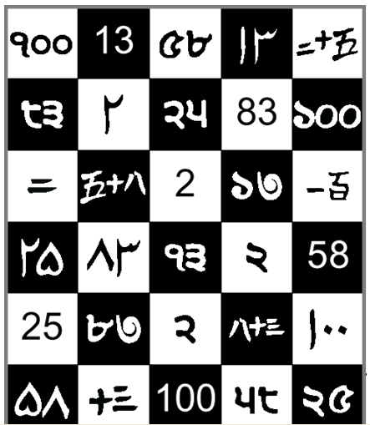

NASA, Aliens and Binary Codes from the Stars

SETI – the Search for Extra Terrestrial Intelligence – has spent the past 50 years scanning the stars looking for signals that could be messages from other civilisations. They look for non-random patterns in data strings that might suggest an advanced culture on another planet.
The desire to encode and decode messages is a very important branch of mathematics – with direct application to all digital communications – from mobile phones to TVs and the internet.
All data content can be encoded using binary strings. A very simple code could be to have 1 signify “black” and 0 to signify “white” – and then this could then be used to send a picture. Data strings can be sent which are the product of 2 primes – so that the recipient can know the dimensions of the rectangle in which to fill in the colours.
If this sounds complicated, an example:
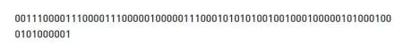
If this mystery message was received from space, how could we interpret it? Well, we would start by noticing that it is 77 digits long – which is the product of 2 prime numbers, 7 and 11. Prime numbers are universal and so we would expect any advanced civilisation to know about their properties. This gives us either a 7×11 or 11×7 rectangular grid to fill in. By trying both possibilities we see that a 7×11 grid gives the message below.

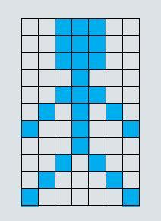

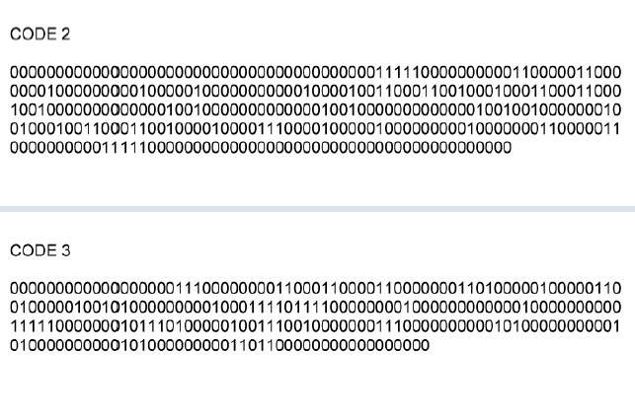
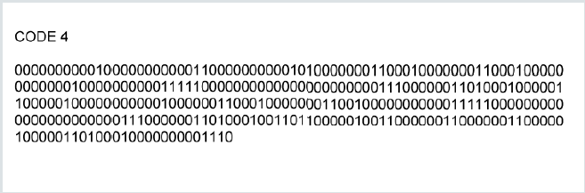

Can you solve the puzzle to find the hidden sentence?

For the puzzle use
X = 2
Y=3
Z= -1
First generate some numbers by substituting the above values into the expressions below. Then convert those numbers into letters using the alphabet converter.
First word: 7y + x, 2y + x, -z, 2(4y+2z)
Second: 5x+z, -y+11x
Third: 7y+z, 4x, 2y+z
Fourth: Y²+3z, y², x² +y² + x + y, (z)² + x⁴ +x, 7y + z
Fifth: 2x³+y, 2y²+z, 7y, -z, (y+x)² + 7z, (x+y)
Sixth: (y+z)⁴ + 2z, 7y, -13z, -2z, x+y, 2y²

Convert your numbers into a hidden message, using the alphabet
A=1, B=2, C=3, D=4, E=5, F=6, G=7, H=8, I=9, J=10, K=11, L=12, M=13, N=14, O=15, P=16, Q=17, R=18, S=19, T=20, U=21, V=22, W=23, X=24, Y=25, Z=26
What is the hidden message? And what is the answer?

Code Challenge

Quick! The evil villain Dr No has stolen a nuclear bomb. The timer is ticking. The government have called on you, knowing that your maths problem solving skills will come in handy. You are humanity’s last hope – don’t let everyone down! The Bomb has an eight number display. You must enter the correct eight digits – or BOOM!

(1)
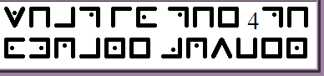
(2)
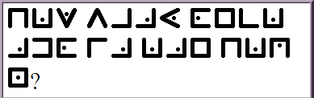
Clue:
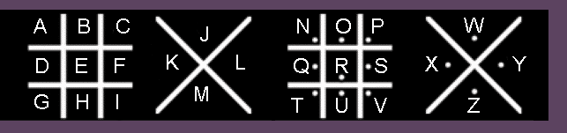
(3)
TEXQ FP PBSBK QFJBP BFDEQ
Clue:
A goes to D

Use Frequency Analysis to Crack the Code.
You are a detective hunting Jack Black – an infamous jewel thief. However, his girlfriend has written a diary entry in code. You suspect that it will reveal where Jack is. If you can crack the code, you can catch him! Quick!

GITW JAJ XRH PIQW AXHR HEK RCCATK; EK YRIUJKJ HEK YBO IH HEK TRUXKU. EK PKXH HR HEK IAUZRUH. EK HROOKJ EAO YUAKC TIOK AX HEK HUIOE. EK QRRWKJ IH I FIZ RC HEK PRUQJ, YRBSEH I HATWKH HR ZIUAO, IXJ XKNKU QRRWKJ YITW.

Most frequent letters in the alphabet.
E | T | A | O | I | N | S | H | R | D | L | U | C
12.7 | 9.1 | 8.2 | 7.5 | 7.0 | 6.7 | 6.3 | 6.1 | 6.0 | 4.3 | 4.0 | 2.8 | 2.8
M | W | F | Y | G | P | B | V | K | X | J | Q | Z
2.4 | 2.4 | 2.2 | 2.0 | 2.0 | 1.9 | 1.5 | 1.0 | 0.8 | 0.2 | 0.2 | 0.1 | 0.1

Most frequent letters in the decoded note.
Individual letters:
14 times A
5 times B
6 times C
9 times D
22 times E
4 times F
1 times G
13 times H
9 times I
1 times J
6 times K
4 times L
1 times M
7 times N
16 times O
3 times P
0 times Q
10 times R
7 times S
19 times T
2 times U
1 times V
3 times W
0 times X
0 times Y
0 times Z

Code Challenge (more difficult)

Quick! The evil villain Dr No has stolen a nuclear bomb. The timer is ticking. The government have called on you, knowing that your maths problem solving skills will come in handy. You are humanity’s last hope – don’t let everyone down! The Bomb has a three number display. You must enter the correct eight digits – or BOOM!

(1)
WIEYNMMHSOEPEBATNVRNETHLEIUR
Clue: This is a transposition cipher. Write the text in 4 lines of 7, one line under the other. See If you can find the hidden message!
(2)
XIBU JT UISFF TRVBSFE
Clue: This is a Caesar cipher. You need to see how many letters the alphabet
has been shifted by. Maybe look for which letters occur most often. Maybe these could be vowels!

(3) IHTAAETALKCUTYWDOHAGRNBUW
Clue: This is a Vigenère Cipher – encoded with the key word Maths. Use the grid below to help translate. Look at the M row first. Find I in it as this is the first letter in the code. Now look at the letter above I in the top row. This is the translated letter. Now look at the A row. Find H in it as this is the second letter in the code. Look at the letter above it in the top row again. You continue to cycle through the letters of MATHS
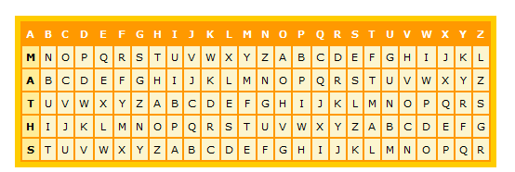
Cracking RSA Code – The World’s Most Important Code?
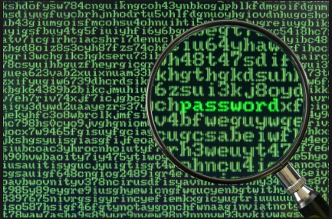
RSA code is the basis of all important data transfer. Encrypted data that needs to be sent between two parties, such as banking data or secure communications relies on the techniques of RSA code. RSA code was invented in 1978 by three mathematicians (Rivest, Shamir and Adleman). Cryptography relies on numerous mathematical techniques from Number Theory – which until the 1950s was thought to be a largely theoretical pursuit with few practical applications. Today RSA code is absolutely essential to keeping digital communications safe.
To encode a message using the RSA code follow the steps below:
1) Choose 2 prime numbers p and q (let’s say p=7 and q=5)
2) Multiply these 2 numbers together (5×7 = 35). This is the public key (m) – which you can let everyone know. So m = 35.
3) Now we need to use an encryption key (e). Let’s say that e = 5. e is also made public. (There are restrictions as to what values e can take – e must actually be relatively prime to (p-1)(q-1) )
4) Now we are ready to encode something. First we can assign 00 = A, 01 = B, 02 = C, 03 = D, 04 = E etc. all the way to 25 = Z. So the word CODE is converted into: 02, 14, 03, 04.
5) We now use the formula: C = y^{e} (mod m) where y is the letter we want to encode. So for the letters CODE we get: C = 02⁵ = 32 (mod 35). C = 14⁵ = 537824 which is equivalent to 14 (mod 35). C = 03⁵ = 33 (mod 35). C = 04⁵ = 1024 which is equivalent to 09 (mod 35). (Mod 35 simply mean we look at the remainder when we divide by 35). Make use of an online modulus calculator! So our coded word becomes: 32 14 33 09.
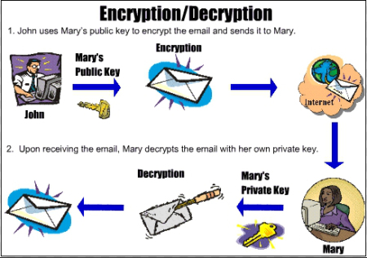

This form of public key encryption forms the backbone of the internet and the digital transfer of information. It is so powerful because it is very quick and easy for computers to decode if they know the original prime numbers used, and exceptionally difficult to crack if you try and guess the prime numbers. Because of the value of using very large primes there is a big financial reward on offer for finding them. The world’s current largest prime number is over 17 million digits long and was found in February 2013. Anyone who can find a prime 100 million digits long will win $100,000.
To decode the message 11 49 41 we need to do the following:
1) In RSA encryption we are given both m and e. These are public keys. For example we are given that m = 55 and e = 27. We need to find the two prime numbers that multiply to give 55. These are p = 5 and q = 11.
2) Calculate (p-1)(q-1). In this case this is (5-1)(11-1) = 40. Call this number theta.
3) Calculate a value d such that de = 1 (mod theta). We already know that e is 27. Therefore we want 27d = 1 (mod 40). When d = 3 we have 27×3 = 81 which is 1 (mod 40). So d = 3.
4) Now we can decipher using the formula: y = C^{d} (mod m), where C is the codeword. So for the cipher text 11 49 41: y = 11³ = 08 (mod 55). y = 49³ = 04 (mod 55). y = 41³ = 6 (mod 55).
5) We then convert these numbers back to letters using A = 00, B = 01 etc. This gives the decoded word as: LEG.

Maths Murder Mysteries

These 2 resources have been inspired by the excellent Cryptography Supersleuth Game also on TES here: (http://www.tes.co.uk/teaching-resource/Cryptography-Supersleuth-Game-KS3-Mystery-6022982/ ) so if you enjoy this one, please check that one out as well. A murder in the maths department, with clues to solve to reveal the murderer. There are different styles of codes to vary things - and the clues are such that you can fill in the names of the teachers or people you want to use for your game!

Maths Murder Mystery 1

A murder has been committed in the maths department! A body has been discovered surrounded by mathematical objects and only the hardworking maths teachers were in school, doing long division sums for fun at the weekend. So one of them must be the murderer!
Your task, should you choose to accept it, is to find:
1) the murderer
2) the room
3) the murder weapon
Work quickly - who knows who could be next!
Possible murder suspects:
1) INSERT TEACHER NAME 1 - who was wearing a white, T-shirt with 2 stripes and ripped jeans on the day of the murder.
2) INSERT TEACHER NAME 2 - who was wearing a knee-length green skirt, white blouse and gold watch.
3) INSERT TEACHER NAME 3 - who was wearing a blue Adidas T-shirt with 3 stripes on the sleeves, Bermuda shorts and a baseball cap.
4) INSERT TEACHER NAME 4 - who was wearing a black and white pin-stripe suit with shiny black shoes.
5) INSERT TEACHER NAME 5 - who was wearing a blue knitted jumper with a picture of pi on the front, and brown cords.
Possible rooms:
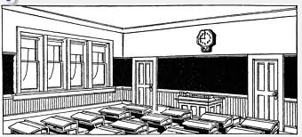
1) The Canteen
2) The Tuck-shop
3) Room 20
4) Room 18
5) Room 17
6) Room 7

Possible murder weapons:
1) A wooden metre ruler
2) A large metal stapler
3) A dusty trundle wheel
4) A sharp compass
5) A large maths textbook
6) An oversized calculator

Clue number 1:
PDA NKKI PDA IQNZAN PKKG LHWYA EJ EO W JQIXAN.
Hint: Maybe some frequency analysis would help crack this Caesar Cipher?

Clue number 2:
Ht me ru ed er hr da ta po no ht ta ah sd rt pi se
Hint: maybe letters could be swapped around somehow?

Clue number 3:
tcejbolatematonsawnopaewredrumeht

Clue number 4:
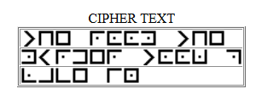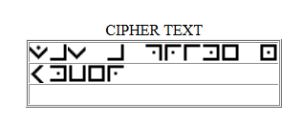
Clue number 5:
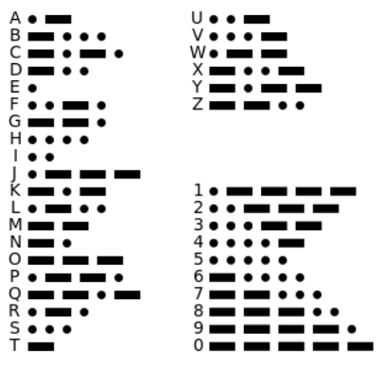
1 0000 0 0101 0 00 000 01 1 0 1001 1 1000 111 111 101 11 00 000 000 00 10 110

Clue number 6:

TRTURKCIURYPODUHOHRTPESMMPLNECIOEDOLIABAEESRKSMMEOANNENOCILY

Hint: Could splitting this into 4 lines of equal length help?

Clue number 7:
FHXTMDDXYWDWTZOQAKPFSTKVMEEKZ
Hint - Go along the M row and find F. What letter is above it on the top row? Now perhaps go to the second row.....

Clue number 8:
ʇɥǝ unɯqǝɹ oɟ sʇɹıdǝs ou ʇɥǝ ʇ sɥɹʇ ıs ɐu ǝʌǝu dɹıɯǝ unɯqǝɹ

Maths Murder Mystery Solutions
Answer 1

Caesar Shift A - E
THE ROOM THE MURDER TOOK PLACE IN IS A NUMBER

Answer 2

Transposition - swap every 2 grouping of letters around - so ht becomes th, me becomes em

the message then becomes:
Th em ur de re r h ad a t o p on th at ha d s tr ip es.

The murderer had a top on that had stripes

Answer 3

Read the message backwards:

The murder weapon was not a metal object

Answer 4

The room the murder was committed in was a prime number

Answer 5

1 represents a dash, 0 represents a dot.

There is a textbook missing
Answer 6

Write in 4 lines from left to right as:

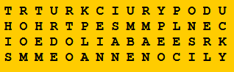

Now read down the columns to get:

THIS ROOM THE MURDER TOOK PLACE IN IS A NUMBER MANY PEOPLE CONSIDER LUCKY

Answer 7:

Vigenere Cipher:
FHXTMDDXYWDWTZOQAKPFSTKVMEEKZ
Look in the M row - find where F is, what letter is above it in the top row? T
Look in the A row - find where the H is, what letter is above it in the top row? H etc.
THE MURDERER WAS WEARING TROUSERS

Answer Number 8:

Upside down mirror writing:
the number of stripes on the t shirt is an even prime number

COMPLETE ANSWER:

Murderer - TEACHER NUMBER 1
Room - 7
Murder Weapon - Textbook

Maths Murder Mystery 2

Another murder has been committed in the maths department! A body has been discovered surrounded by mathematical objects . Once again and only the hardworking maths teachers were in school, memorising pi to 200 digits for fun at the weekend. So one of them must be the murderer!

Your task, should you choose to accept it, is to find:
1) the murderer
2) the room
3) the murder weapon
Work quickly - who knows who could be next!
Possible murder suspects:
1) INSERT TECHER NAME 1 - who was wearing a white, T-shirt with 2 stripes and ripped jeans on the day of the murder.
2) INSERT TEACHER NAME 2 (female) - who was wearing a knee-length green skirt, white t-shirt and gold watch.
3) INSERT TEACHER NAME 3 - who was wearing a blue vest, Bermuda shorts and a baseball cap.
4) INSERT TEACHER NAME 4 (female) - who was wearing a black and white t-shirt with an odd number on it, trousers and shiny black shoes.
5) INSERT TEACHER NAME 5 - who was wearing a blue knitted jumper with a picture of pi on the front, and brown cords.
Possible rooms:
1) The Canteen
2) The Tuck-shop
3) Room 16
4) Room 25
5) Room 17
6) Room 1

Possible murder weapons:
1) A wooden metre ruler
2) A large wooden cube
3) A dusty trundle wheel
4) A sharp compass
5) A large maths textbook
6) An oversized calculator
Clue Number 1
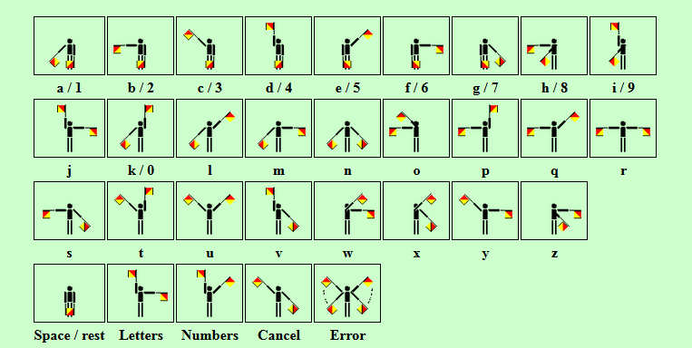
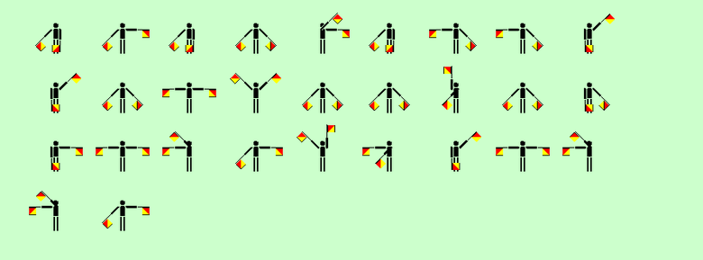
Clue Number 2
Clue number 3
PAXG RHN WXVBIAXK MABL FXLLTZX BG YNEE RHN PBEE LXX MATM MAX FNKWXKXK PTL PXTKBGZ T M LABKM

Clue number 4
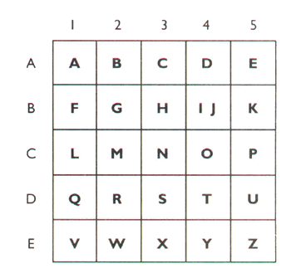
D4, B3, A5, C2, A1, C3, E2,B3,C4, D2,A1,C3, B1,D2,C4,C2,D4,B3,A5, D2,C4,C4,C2, B4, D3, C3,C4, D4, B2, D5, B4, C1, D4, E4
Clue number 5
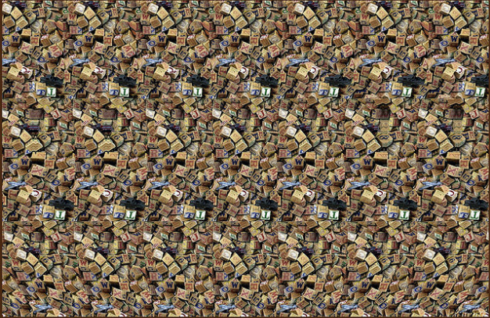
This object was found lying by the victim

Clue 6
TSRROLEAOIAVNBHMDTKAIRMTNEUEIUEOPCNOWHENMR
(Hint: Transposition Cipher)

Clue 7: What the murderer was wearing:

0010001100101000010011111
Hint: How can you make a picture from this code and the table above?

Answers
Clue 1:
A man was seen running from the room
More Semaphore codes from here (http://geocaching.marckoppert.com/geocacheTools.php?lang=en&page=semaphoreFlags)

Clue 2:
The room is a square number (Mirror writing)
More mirror writing codes from: http://txtn.us/mirror-words
Clue 3:
Use frequency analysis to see that the most common letter in the code is x. This therefore goes to e in a Caesar Shift.
WHEN YOU DECIPHER THIS MESSAGE IN FULL YOU WILL SEE THAT THE MURDERER WAS WEARING A T SHIRT
Clue 4:
The man who ran from the room is not guilty
Clue 5:
Magic Eye – stare through the page to see a cube.

Clue 6:
Transposition Cipher in 3 lines:
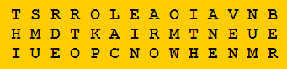
THISMURDERTOOKPLACEINAROOMWITHANEVENNUMBER
Clue 7:
Work from top left across the table – colour in each square for a 1 and leave blank for 0. (so the top row is blank, blank, black, blank, blank) You should end up with a picture of the number 1.
Solution:
Teacher Number 4 is Guilty
Murder Weapon is the large wooden cube
Room is 16.

Other Solutions

Caesar Shift
- Caesar Shift A goes to D. CONGRATULATIONS YOU HAVE CRACKED THE CAESAR SHIFT CODE
- A goes to T WHAT IS THE FIFTH TRIANGULAR NUMBER?
Transposition Cipher

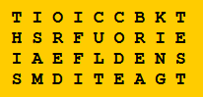
THIS IS A MORE DIFFICULT CODE BREAKING TEST

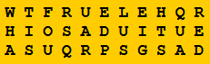
WHAT IS FOUR SQUARED PLUS EIGHT SQUARED?

Frequency analysis

JACK DID NOT WALK INTO THE OFFICE HE BOARDED THE BUS AT THE CORNER HE WENT TO THE AIRPORT HE TOSSED HIS BRIEF CASE IN THE TRASH HE LOOKED AT A MAP OF THE WORLD BOUGHT A TICKET TO PARIS AND NEVER LOOKED BACK

Vignette Ciphers

- BPRLB XBYWM JVKZY NJFFT HKZFN RJVJ - WHAT IS THE TENTH FIBONACCI NUMBER
- TOPTS ZYLLU ANWZA ZAWHQ - HOW MANY SECONDS IN A DAY
See http://www.math.tamu.edu/~dallen/hollywood/breaking/v.htm for more Vignette Ciphers.

Solution ISBN
- Yes
- No
- No
- 3 – using x as the missing number we end up with 5x + 7 = 0 mod 11. So 5x = 4 mod 11. When x = 3 this is solved.

Solution to Credit card
The second one is genuine
Solution to Enrich Problem
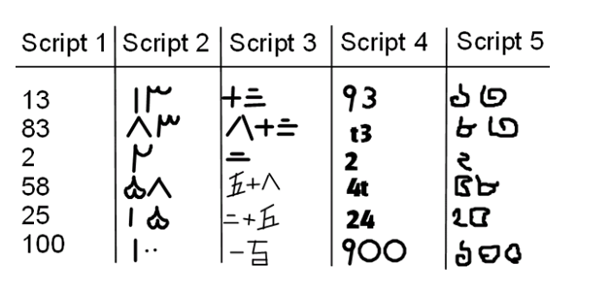

Solution to NASA codes
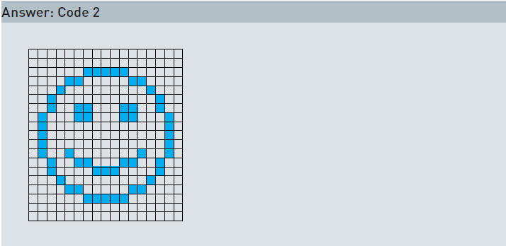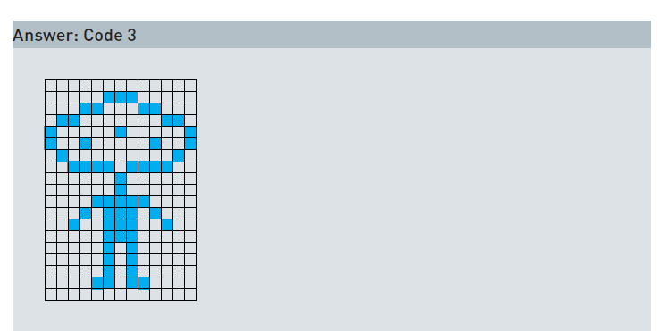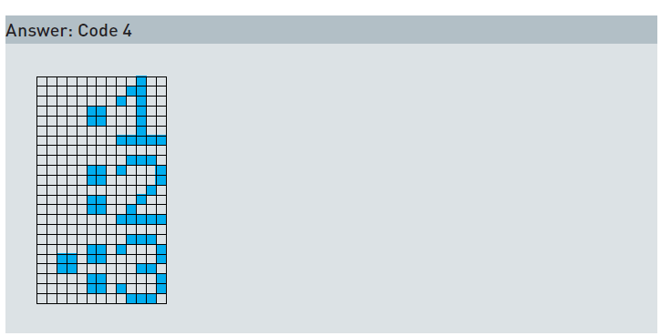

More code questions in the Maths Illuminated course on primes from learner.org

Solution to hidden sentence puzzle:
What is the first square number? Answer 1

Solution to code challenge 1

1) What is the 4th square number - 16
2) How many seconds in one hour? - 3600
3) WHAT IS SEVEN TIMES EIGHT - 56
Solution to code challenge 2

Teacher note – this works best as a paired activity – otherwise it could take too long. Also you might need to give some clues (eg – the first word is jack etc)
Jack did not walk into the office; he boarded the bus at the corner. He went to the airport. He tossed his brief case in the trash. He looked at a map of the world, bought a ticket to Paris, and never looked back.

Solution to Code Challenge 3
This is a transposition cipher so rearrange WIEYNMMHSOEPEBATNVRNETHLEIUR
to give:
WIEYNMM
HSOEPEB
ATNVRNE
THLEIUR
Then read downwards to get: WHATISTHEONLYEVENPRIMENUMBER?
Answer is 2.
2) XIBU JT UISFF TRVBSFE
Translates to:
WHAT IS THREE SQUARED = 9
Using a Caesar cipher where B goes to A etc.
3) Following the instruction we get: WHATISTHESQUAREROOTOFNINE = 3
Final code = 293

Resources

- The Counton website has a large number of code generators for Caesar shifts, transposition ciphers, pigpen and Vignere codes (http://www.counton.org/explorer/codebreaking/transposition-ciphers.php)
- The learner.org website has more binary string codes (http://www.learner.org/courses/mathilluminated/pdf/MathIlluminated_01_txt.pdf)
- Additional resources for creating Vignere codes (http://www.math.tamu.edu/~dallen/hollywood/breaking/v.htm)
- Additional resources for creating Semaphore codes
(http://geocaching.marckoppert.com/geocacheTools.php?lang=en&page=semaphoreFlags)
- Additional resources for mirror writing codes (http://txtn.us/mirror-words)
- Morse Code generator (http://www.glassgiant.com/geek/morse/)

