3.1 Energy

Task 1 | Energy Research

Group | Non-renewable energy resources | Renewable energy resources
1 | Oil | wind | tidal | waves
2 | Coal | biomass | solar | hydroelectric
3 | Gas | geothermal | wind | biomass
4 | Coal | tidal | solar | geothermal
5 | Oil | waves | hydroelectric | tidal
6 | Gas | solar | waves | wind
7 | Coal | hydroelectric | geothermal | biomass
8 | Oil | solar | biomass | wind
Decide which energy resources you will research. Research 3 -5resources, try to include at least 1-2 types of renewable or non-renewable.
- Give a few advantages and disadvantages for each resource type.
- Use the link below to help with your research.

nationalgeographic.com/environment/energy/reference/renewable-energy/

 | Energy transfer
Task 1 |  | Energy stores

 | Type of energy store | Definition | Example | Energy store before | Energy store after
1. | Chemical energy store | Energy that is stored in the bonds between atoms that make up the substance. | A lamp burns oil which is a fuel. | More energy | Less energy
2. | Elastic energy store |  | An elastic band is stretched.
3. | Gravitational potential energy store |  | A box falls off a shelf.
4. | Kinetic energy store |  | A bike accelerates.
5. | Thermal energy store |  | A saucepan of soup is heated up.
There are five types of energy stores. Energy is transferred between energy stores. Fill in the table (the first row has been filled in for you).

Challenge questions:
Can you think of examples where the opposite energy transfers will happen? Write them down.
Think about a car that is driving at a constant speed. What do you think is happening to its kinetic energy store?

 | 3.2 Energy transfer
Task 2 |  | Energy transfer

Choose three of the examples of energy transfer from the table below (or you could use your own).
Example
A lamp burns oil which is a fuel.
An elastic band is stretched.
A box falls off a shelf.
A bike accelerates.
A saucepan of soup is heated up.

Draw diagrams to show how the energy is transferred in each case.
Include energy stores, energy transfers and dissipated energy. Show clearly how the total energy in each example remains the same.

Eg. Lamp Oil Light Energy
Chemical energy transfers to ( Useful energy)
Sound Energy
Energy is lost as Light Energy
(wasted energy)

 | 3.4 Heating and cooling
Task 1 |  | Designer coats

You are part of a team that is designing a new range of winter coats for dogs.
You need to choose the best material to make the coats from.
- Write down three properties that the material needs to have.
- Plan an experiment to test which material is the most effective insulator. You could draw a diagram or write a short description of your plan.
  - You will have access to lab equipment such as thermometers, beakers, stopwatches, hot water, etc.

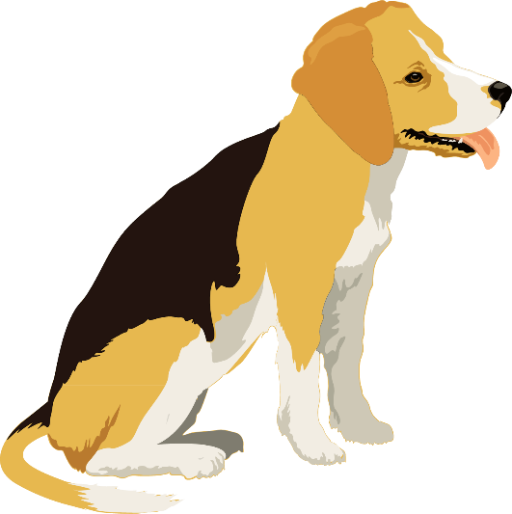

 | 3.4 Heating and cooling
Task 2 |  | Take-away tasks

*  Know | Name five materials that are good conductors.  Name five materials that are good insulators.
*  Know | Name the three pathways by which thermal energy can be transferred.  Write a definition for each.  Choose one and draw a diagram to show how it transfers energy.
**  Apply | Convection currents are common in lots of everyday situations.  Choose two examples from the list:  lava lamp, hot air balloon, kettle, air conditioner, sea breezes, radiator, fridge  For each example you have chosen, draw a diagram to explain the convection current involved.
*** Extend | Find out what is meant by a ‘zero-energy’ house.  Imagine that a new estate of zero-energy houses is being built nearby.  The housing company wants to advertise the new estate on their website to new buyers and tenants.  Write an information page for the website (this could be done on paper or a presentation slide).  It should …  - describe what a zero-energy house is and its advantages  - explain how it reduces the transfer of energy and also generates energy.

