Christianity Beliefs and teachings revision guide
Version 1.3 - GRH
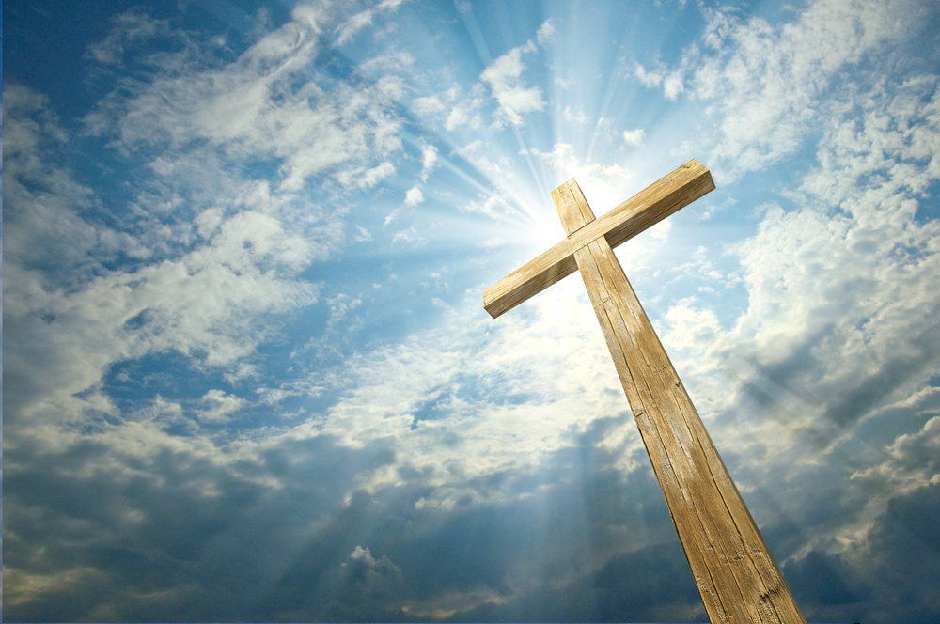
Key Terms
Key Word | Definition
Agape | Christian love.
Apostles Creed | A statement of Christian belief from the Early Church.
Anglican | A worldwide denomination that includes the Church of England.
Ascension | Jesus being taken up to heaven on the 40th day after Easter.
Atonement | The action of making amends for wrong doing.
Baptism | A ceremony to welcome a person into the Christian religion.
Catechism of the Catholic Church | A summary of Roman Catholic teaching.
Crucifixion | A capital punishment used by the Romans which nails a person to a cross to kill them.
Denomination | The name for the different branches of the Christian church.
Fundamentalist | Christians who take the Bible literally, i.e. word for word true.
Genocide | The deliberate and indiscriminate killing of a group of people, belonging to a particular ethnic group or nationality.
Gospel | The names of the books about the life of Jesus in the Bible: Matthew, Mark, Luke and John.
Grace | Unconditional love that god shows to people who do not deserve it.
Historic Truth | Facts about historic events, usually from evidence
Incarnation | God in human form.
Lord’s Prayer | The prayer Jesus taught his disciples to show them how to pray.
Messiah | The anointed one who is seen as the saviour by Christians.
Miracles | Events that have no scientific explanation for them happening; these were performed by Jesus and described in the Gospels.
Mission | An organised effort to spread the Christian message.
Nicene Creed | A statement of belief used in Christian services.
Non-liturgical worship | Informal structure found in some church services.
Omnipotent | The idea that God is all-powerful.
Oneness of God | The idea that God is ‘one’.
Penitence | To feel regret for someone’s sins.
Protestant | A branch of the Christian church that broke away from the Roman Catholic Church.
Reconciliation | The process of making people in conflict friendly again.
Religious Truth | Knowledge gained through interpretation of religious texts, rather than taking them literally
Resurrection | The physical return of Jesus on the third day after he died.
Roman Catholic | The largest Christian group, based in Rome with the Pope as its leader.
Salvation | The saving of the soul from sin.
Sanhedrin | The ruling council of Jews in Israel.
Secular | Relating to worldly as opposed to religious things.
St Paul | A man who taught the teachings of Jesus – originally Saul of Tarsus before his conversion.
Trinity | The belief in God the father, God the Son and God the Holy Spirit.

Question 1
The 1 mark question
- Multiple choice
- There will always be four options given
- This style of questions features on both paper 1 and paper 2
- The distractors will not be trivial
Paper 1 – example from Christian beliefs
Which one of the following is the idea that God is three-in-one?
- Atonement B) Incarnation C) Salvation D) Trinity

Mark scheme content:
D) Trinity

…………………………………………………………………………………………………………………………………………
Question 2
The 2 mark question
- One mark for each relevant point
- A short answer is expected

Paper 1 – Example from Christian beliefs
Give 2 qualities which Christians believe describe the nature of God
Mark scheme content:
Omnipotent/ loving/ just/ one/ trinity/ merciful/ forgiving/ omniscient/ eternal

…………………………………………………………………………………………………………………………………………
Question 3
The 4 mark question
- Influence tested in ‘beliefs’ section of Religion paper

You need to give two answers – each one is worth 2 marks
1 mark = Simple explanation of a relevant and accurate answer
2 marks = Detailed explanation of a relevant and accurate answer
Influence
Paper 1 – Example from Christianity beliefs.
Explain two ways in which belief in the resurrection of Jesus influences Christians today.
Influence 1: Belief in the resurrection of Jesus gives Christians faith that they will be raised from the dead. This helps them overcome fear of death and encourages some to lay down their life foe their faith. (2 marks)
Influence 2: It also creates faith that good can triumph over evil. This helps Christians face persecution and suffering (2 marks)

Here two influences are explained in detail. In each instance, the first sentence offers a ‘basic explanation’; the second turns this into a ‘detailed explanation’
…………………………………………………………………………………………………………………………………………
Question 4
The 5 mark question
- Different from the 2 mark question as you need an explanation from each belief
- A simple explanation is worth one mark, a detailed explanation is worth 2 marks
- One extra mark is gained by accurate/relevant reference to a quote from a sacred text.

Paper 1 – example from Christian beliefs
Explain two Christian beliefs about the incarnation of Jesus
Refer to Christian teachings in your answer.
Christians believe that Jesus is both fully human and fully divine. This is called the ‘hypostatic union’. In the Nicene Creed it states that Jesus was ‘begotten of the Father, not made’, suggesting that he is more than just a human, but God incarnate.
Christians also believe that the incarnation of Jesus is an example of Gods loving nature. The New Testament teaches that Jesus’ death was an atoning sacrifice for the sins of human beings, so that the relationship between humans and God could be restores. Christians are encouraged to demonstrate this love to one another. (5 marks)
T

Two reasons have been given with reference to Christian teachings.

…………………………………………………………………………………………………………………………………………
Question 5 – The BIG one worth 12 marks
- You should assess different viewpoints
- In the study of religions, different views within a religion should be used.
- In the thematic questions you must include the views of at least on religion you can also use non-religious views in these questions.
- You need a justified conclusion
- Each argument must be backed up with evidence – quotes.

Criteria | Marks
A well-argued response, reasoned consideration of different points of view. Logical chains of reasoning leading to judgment(s) supported by knowledge and understanding of relevant evidence and information.  References to religion applied to the issue. | 10-12
Reasoned consideration of different points of view. Logical chains of reasoning draw on knowledge and understanding of relevant evidence and information  Clear references to religion. | 7-9
Reasoned consideration of a point of view. A logical chain of reasoning drawing on knowledge and understanding of relevant evidence and information.  Or  Recognition of different points of view, each supported by relevant reasons/evidence.  Maximum of 6 marks if there is no reference to religions or the argument is one-sided. | 4-6
Point of view with reason(s) stated in support. | 1-3

Example one - Paper 1 Christian beliefs
In this answer below developed arguments have been presented in support of the statement and against it followed by a justified conclusion. The arguments against the proposition are more fully developed, but this satisfies expectations for a Level 4 answer. Note that this answer, to a Paper 1 study of religion question, is rooted in the differing perspectives within the given religion.
“If God were loving. There would be no suffering in the world.’
The arguments for this view are very strong. Every day we hear about some natural disaster or terrible act of human wickedness. Most people are horrified and feel pity for the victims. If they could, they would prevent such suffering. So how can there be an an-loving God? Surely a loving God would do something to stop such evils happening. Surely he would have created a world where they could not occur. It really seems as if God does not care.
What makes it even worse is that so often those who suffer the most have done nothing to I deserve it, e.g.· Young children born with painful, life-limiting conditions. If there is a loving God why does he not protect the innocent and vulnerable, as he told the Jews to do in the Old Testament?
Christians challenge this view in various ways. One argument is that suffering enables spiritual growth. It brings out the fighting spirit in us that enables us to develop into mature humans. It encourages us to feel compassion for and want to relieve the suffering of others. Christians believe that suffering also deepens their relationship with God. They realise that they are not self-sufficient, and their trust in him enables them not just to cope but to triumph over suffering.
Most Christians also believe that suffering is inevitable if we are to be totally free. God’s gift of free will is one of his most precious gifts and without it we would be no more than puppets or a string. Genuine freedom means the freedom to make good and bad choices, to show love for others or to inflict suffering.
The arguments in support of the statement are persuasive. It is certainly true that suffering often seems to be excessive and pointless and that it often targets the innocent. Nevertheless, the counter-arguments are even stronger. Without suffering we would never fully appreciate true happiness and joy. If the weather was always beautiful sunshine life would be boring but because we have times when it’s wet and miserable, days when the sun shines are special. God in his love designed the world to enable us to experience the fullness of life. Moreover, we learn from suffering as much of it is caused by human action. God has given us the priceless gift of free will and if we misuse it by, for example, going to war or taking illegal drugs then suffering results. God allows us to learn from our mistakes but he also in love allowed his only Son, although totally innocent, to be crucified so that we could be forgiven for our wrongdoing. What a greater love could be shown than this, thus showing that God is love and that the statement is incorrect!

NATURE OF GOD
Christians believe God is:  - OMNIPOTENT – this means all powerful. Nothing is impossible for God.  - However, God only performs actions in accordance with his own nature. Even though nothing is impossible for God, there are many things God would not do.  - The created universe is evidence of God’s omnipotence – only a powerful God could do that  - Miracles are also evidence of omnipotence e.g. St. Bernadette at Lourdes | Christian teachings about God’s omnipotence  - The creation story – God creates the universe in 6 days  - Noah’s flood – God floods the entire earth for 40 days  - 10 Plagues of Israel – God sends 10 plagues against the Egyptians as a punishment  - Marks Gospel – Jesus calms a storm. Jesus orders the storm to stop, and it does. Also evidence of Jesus’ divinity  Some people might believe that stories about God’s omnipotence are just stories. They might argue that the Church made them up to show how powerful God is. There might also be natural explanations for miracles.
Christians believe God is:  - OMNIBENEVOLENT – this means all loving. God is the source of goodness and love in the world  - God’s love is called “agape” –this is a Greek word meaning ‘selfless’ or ‘unconditional love’  - This means God’s love is universal – it is for everyone, Christian or not  - God’s Omni benevolence is linked to beliefs about salvation and atonement (see: Salvation)  - Some people find it difficult to believe that God is all loving, as there is so much suffering in the world (see: Problem of Evil)  - Others might feel that suffering allows them to help others, and practice agape love themselves. | Christian teachings about God’s omnipotence:  - John 3:16 – “God so loved the world that He gave His only son” – Jesus was sacrificed so that the world could be saved. This is an example of agape, or selfless love, that Christians might follow in their own lives  - The Parable of the Prodigal Son – Jesus tells the story of a spoiled son who leaves home and spends all his inheritance. His father welcomes him home and forgives him, even though he doesn’t deserve it. This is an allegory for God’s loving and forgiving nature.
Christians believe God is:  - JUST – this means ‘fair’ (think ‘justice’). Christians believe that God does not discriminate, and expects his followers to treat people fairly as well.  - Atheists might argue that God is not just, because people suffer when they don’t deserve it. Steven Fry used the example of insects that burrow from the eyes of children and make them blind.  - Christians like John Hick might argue that suffering seems unfair, but there is an unexplained purpose to it. Christians need to accept what they don’t understand and trust God. | Christian teachings about God’s justice:  - The Decalogue, or 10 commandments, were rules given by God to Moses to ensure that people lived a good and fair life – Christians and Jews aim to follow these rules  - The Parable of the Sheep and Goats teaches that all people will be judged on how they have lived, and the good will be rewarded, and the wicked will be punished. People who suffer in this life will not always suffer.  - The prophet Amos taught ‘let justice roll on like a river’ – this suggests that Christians should encourage justice in the world, and work towards making it a fairer place e.g. charity work.
How these beliefs influence Christians

Beliefs about the nature of God might influence Christians in the following ways:
- The belief that God is all powerful might lead Christians to believe in miracles, such as miraculous healing. As a result they may pray for God to help people who are sick or dying.
- The belief that God is loving might lead Christians to follow his example and treat others according to agape love. This might mean they offer help and support to all people, not just those that they personally know
- The belief that God is just means that Christians believe that God will judge them fairly based on how they have lived their lives. They know that they will be punished for their bad deeds, and also rewarded for their good deeds
- The belief that God is just, and that God is loving, might mean that Christians volunteer for charitable organisations to help those who are less fortunate. This is a way of practicing agape, and also creating a fairer society.

ONENESS OF GOD AND TRINITY
- Christianity is monotheistic – this means they worship only one God.  - God’s nature is understood in three ways:  - The creator and sustainer of the universe (God the Father)  - The saviour, who lived, died, and lived again (God the Son)  - The source of strength that Christians find at work in their hearts (God the holy spirit)  - The Trinity is a way of understanding the complex nature of God – God is a Trinity of three ‘persons’ or aspects.  - Some people find the Trinity difficult to understand. However, God’s true nature is beyond human understanding – this is one way of trying to make more sense of it  - Symbols of the trinity show the idea of ‘three in one’. They each symbolise that the three persons of God are part of the same whole. Some examples include:  - Equilateral triangles  - Shamrock  - Borromean rings | Christian teachings about the Trinity  - During the baptism of Jesus, a voice from Heaven states ‘You are my beloved Son’. At the same time, the author describes the Holy Spirit descending ‘like a dove’. All three persons of the Trinity are present at this time.  - Before the ascension, Jesus tells his followers to “make disciples of all nations - baptise in the name of the Father, Son, and Holy Spirit”  - During baptism services, Christians are baptised ‘in the name of the Father, Son, and Holy Spirit’, as Jesus commanded.  - Christian prayer often refers to the idea of the Trinity.  - The Trinity is also a key part of both the Apostle’s Creed and the Nicene Creed
How belief in the Trinity influences Christians

- The trinity demonstrates unity between the different persons of God. Each is a part of a greater whole. Similarly, Christians believe they should show similar unity in their lives, and be respectful and loving towards others
- Belief in the Trinity influences worship – prayers, church services, and hymns contain references to it.
- Belief in the trinity also makes Christianity unique amongst world religions, and a Christian may take their faith more seriously as a result
Arguments against belief in the Trinity
- Not all Christians are Trinitarian. Some Christians believe the Trinity does not make sense and that there is only one God – two examples of these are Unitarians, and Jehovah’s Witness’. Some people think belief in the Trinity is so important that these groups are not denominations of Christianity at all, but a separate religion.
- Some religious groups believe that Christianity actually worships three separate Gods, who are linked. This is called tritheism.
- Atheists, such as Richard Dawkins, might argue that because the Trinity is a complex idea that does not make logical sense, that this confirms the view that religion is outdated and based on superstition, rather than factual evidence.
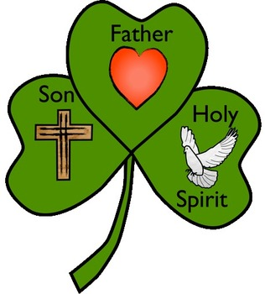
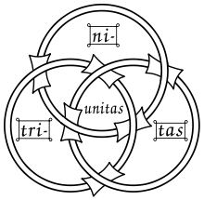
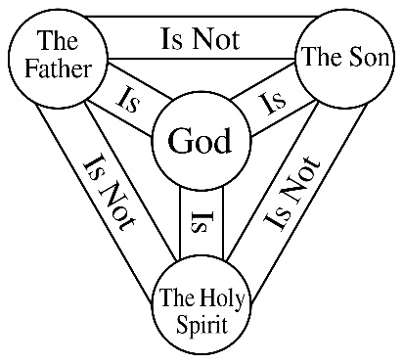

THE PROBLEM OF EVIL
- Christians believe that God is all loving, all knowing, and all powerful. They also believe that God is fair  - The problem of evil is as follows:  - A powerful God could prevent suffering  - A loving God would want to prevent suffering  - An all knowing God would know how to prevent suffering  - A just God would not allow suffering  - However, suffering exists. This means that either God does not exist, or he does not have the qualities Christians believe he has.  - This is also called the ‘Inconsistent Triad’ – suffering cannot exist if God is both loving and powerful. One of those three things must be false  - Moral evil = suffering caused by the choices of humans  - Some Christians believe the Devil tempts humans to make wrong choices – this would mean that the Devil is responsible for evil  - Other Christians believe that God gave humans free will. If they choose to do evil things, that is not God’s fault  - Natural evil = suffering caused by the natural world. As this was created by God, many people feel God is responsible for this kind of evil. | Christian teachings about suffering and evil  - The story of Adam and Eve teaches how humans disobeyed God. Originally, there was no pain and suffering. Suffering only entered the world because human beings sinned against God. Some Christians believe suffering is a punishment for sin. Another example of this is seen in the story of Noah’s Ark, where God floods the world to remove all the sinful people from it.  - The story of Job offers another possibility. Some people believe that suffering is a test of faith. Humans should trust God through good and the bad. It’s easy to be thankful when things go your way, but more important to keep faith when things go wrong  - The story of Job also implies that suffering is part of God’s plan, and that Christians must trust that there is a purpose to their suffering – even if they cannot understand it.  - St. Irenaeus believed that suffering was a form of education for the soul. It helps us grow spiritually  - St. Augustine believed suffering was a consequence of free will. Suffering occurs because humans make bad choices  - Suffering brings balance to the world. To appreciate good, we must also experience bad.
How beliefs about the problem of evil influence Christians

- If Christians believe that suffering gives them an opportunity to develop and grow spiritually, then they may take that opportunity to help others.
- Additionally, they may believe that it is their responsibility, not God’s, to fix the problems in the world. Most moral evils could be eradicated if people shared wealth more equally and were kinder to one another.
- If suffering is a test of faith then Christians will be more likely to pray for support and guidance

How an atheist might respond to Christian arguments about the problem of evil

- Why would an omniscient (all knowing) God need to test his followers? Surely he would know if they would remain good people without causing suffering
- If suffering is a punishment for sin, why do innocent people suffer? What about young children who have never had the chance to be bad?
- If suffering is a part of God’s plan, then that proves that he is not all loving – only an evil God would plan for millions of people to be affected by war and famine.

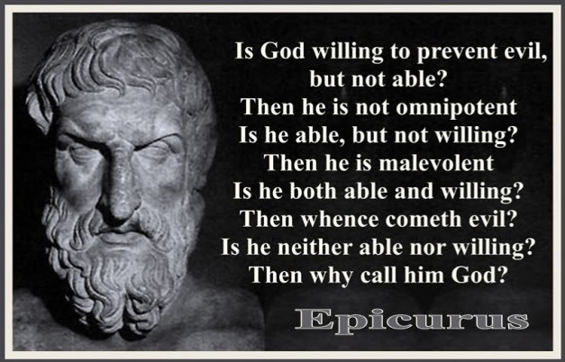
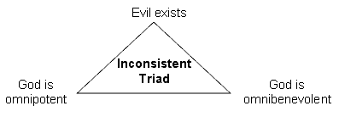
CREATION
- The story of Creation is found the in book of Genesis, in the Old Testament of the Bible  - Genesis teaches that God created the world in 6 days, and rested on the 7th.  - Some Christians believe this story has historic truth because:  - The Bible is the word of God. There are no mistakes in the Bible  - God is all powerful, and it makes sense for an all powerful God to create the universe this way  - Other Christians believe the story has symbolic or religious truth. This means that the story teaches about the nature of God and his relationship with humans. They might believe this because:  - The Bible needs to be viewed in a modern context – science has proven that the Earth is older than the Bible claims it is  - They may believe that religious truths about the relationship between humans and God are more important than the historic truths of what day God created each part of the universe  - Some of the religious truths from Genesis include:  - God is the sole creator and sustainer of the universe  - The universe is ordered, not random  - God created everything in the universe with a purpose  - Humans are created in God’s image, meaning they share some of his qualities e.g. creativity, ability to form relationships, free will  - Humans have a responsibility to care for the world God created., | The role of the Trinity in creation  - God created the world, and God is Trinity. Each part of the Trinity has a role in the act of creation  - The creative, life giving part of God is usually referred to as the Father. Genesis begins with “In the beginning, God created the Heavens and the Earth”, and the Nicene Creed states “We believe in one God, the Father….maker of Heaven and Earth”.  - In John’s Gospel, there is reference to ‘the Word’ – “In the beginning, there was the Word, and the Word was with God, and the Word was God…through Him all things have been made”.  - “Word” refers to Jesus. This shows that Jesus was part of the Trinity long before he became incarnate.  - John’s Gospel states that “the Word became flesh and lived among us for a while”, linking the Word with Jesus.  - This passage also shows the importance of Jesus in creation.  - In Genesis, it states ‘the earth was formless…and the Spirit of God was hovering over the face of the waters’. This is a reference to the Holy Spirit, transforming chaos into order. This image of ‘hovering’ is often compared to a dove, which is a symbol for the Holy Spirit.
How beliefs about creation might influence Christians
- The creation story explores the idea that humans are made ‘in the image of God”. This is hugely important in Christian ethics. All humans deserve respect and fair treatment because all humans are made in the image of God. All human life is valuable, which has an impact on moral issues such as abortion, war, and capital punishment.
- As all humans are equal, Christians may work to promote social justice and equality in society
- Because humans have been given responsibility to care for the world, they may be more likely to work towards promoting environmental issues such as recycling or green energy.
- Because the world is made according to God’s structure and order, there is a purpose to everything that happens. This links with the ‘problem of evil’ topic. This can reassure Christians when things go wrong, that there is a plan behind everything that happens, and they will understand this one day.
Historic vs Religious truth
- Some people may argue that historic truth is more important. Atheists may argue this. Because the timeline of the Biblical creation story has been contradicted by science, atheists may argue that the creation story has no value, as it contains no facts about the created world. Christians who believe in the literal creation argue that scientific evidence is flawed – perhaps God created the world to appear older than it is, or perhaps the Devil is trying to lure people away from God
- Others may argue that the religious truth is more important. This is because historic truth about creation does not give guidance on how to live. It could be seen that it is more important to learn that humans have a special role in creation, and that God expects them to care for the world, than the fact that God created plants on the third day of creation. Religious truths also do not rely on historic events: the importance of humans being made in the image of God remains whether God created the world in 6 days, or whether the world was created by a Big Bang billions of years ago.

THE AFTERLIFE AND JUDGEMENT
- Christians believe in life after death. They believe when they die, they will be judged on how they have lived, and this will affect whether they go to a place of reward called Heaven, or punishment, called Hell  - God is loving and just. Christians trust that he will be fair when they receive judgement. A loving God is one who punishes those who deserve it, as well as rewards those who have earned it  - Catholics believe in two judgements  - The particular judgement happens immediately after death. Most Catholics believe that the dead wait in either peace of torment, for the final judgement.  - The final judgement occurs with the Second Coming (or Parousia) of Jesus. The living and the dead will be judged, and they will be resurrected to live forever with God in Heaven, or away from God in Hell.  - Catholics also believe in purgatory. This is an intermediate state, where the soul waits if it is destined for Heaven. This is a state of cleansing and purification.  - Some Christians believe that there is no second coming. They agree that humans will be judged based on how they have lived, but that the Bible and Jesus were trying to explain the afterlife symbolically.  - They also believe that words cannot explain the afterlife properly, as no living person has ever experienced it/ | Christian teachings about judgement  - The Nicene Creed states that “Jesus will come in glory to judge the living and the dead”. This suggests it is the Son in the Trinity that delivers judgement  - Evidence for the particular judgement comes from a thief who was crucified alongside Jesus, who was told ‘today you will be with me in paradise’, suggesting his judgement would be immediate  - Evidence for the final judgement comes from John’s Gospel, which claims no one has yet entered Heaven – the dead wait for their judgement.  - The Parable of the Rich Man and Lazarus warns of a rich man who is sent to Hell, and is unable to cross from there into Heaven. The consequences of human decisions are permanent  - The Parable of the Sheep and Goats also states that Jesus will return to judge the living and dead, and that he will decide based on whether people chose to help others during their lives, or ignore people who were suffering.
HEAVEN AND HELL  - Christianity teaches that Heaven is a place of peace and reward.  - People often think of Heaven as a place in the clouds, with Pearly Gates. People also think of people as angels, with wings and halos  - The Bible teaches that Heaven is not a physical place, but a state of being. It is existence with God, outside of time and space – an eternity of bliss.  - Hell is described as a place of torment, usually a place of fire  - In the Middle Ages, paintings of Hell (called Doom Paintings) were used to warn people of the consequences of living a bad life, with demons torturing humans.  - More modern interpretations of Hell have it as a state of separation from God. By not following God’s teachings, humans reject him.  - It is therefore human choice, not God’s will, that some humans go to Hell  - Some Christians believe that there cannot be a Hell if God is loving, as a loving God would not send people to eternal punishment for a temporary sin.  - They might also believe that God can forgive any sins, so even a person in Hell can be redeemed. | RESURRECTION  - Christians believe that their body will be resurrected, like Jesus’ was after the crucifixion. They will be given a new, spiritual body, which does not decay, and will live forever.  - Life after resurrection would be very different from mortal life. It is the continuation of an individual, but a different kind of existence. Think about how a caterpillar changes into a butterfly.  - Belief in the resurrection of Jesus is a core part of Christianity. The resurrection is proof that he is the Son of God. It is also proof of life after death for all Christians. St. Paul claimed ‘if Christ had not been raised, your faith is futile’.  - No one really knows what the resurrection will be like – Christians trust that God has the answers
How do beliefs about the afterlife and judgement influence Christians
- If Christians believe their body will be resurrected, then they may choose to be buried rather than cremated. Christians who believe in a spiritual resurrection however may not mind.
- Christian funerals focus on the next stage of an individuals existence, praying for their entry into Heaven
- Christians believe they will be judged on how they have lived, so they will try and follow the teachings in the Bible and care for others so they can go to Heaven
- Christians who believe in Hell may also be less likely to behave badly, out of fear of punishment.

INCARNATION OF JESUS
- Incarnation means ‘in flesh’. It refers to God becoming human and living on Earth in the form of Jesus  - Christians believe God is both fully human, and fully divine. This is called the ‘hypostatic union’. This makes him different from demigods, or half gods, who are common in Roman and Greek mythology (e.g. Heracles)  - This is another concept that is difficult to fully understand and seems to defy logic. However, God is mysterious.  - The Bible teaches that Jesus’ mother Mary was a virgin, and only God could create life this way.  - Some Christians fully accept this – the Bible is the word of God, and an omnipotent God could easily make someone pregnant!  - Others believe that the Nativity stories have religious truths – the events of Jesus’ birth are a mystery, and the Gospel writers created the story to ensure that people understand that Jesus was no ordinary human | Christian teachings about the incarnation  - The Gospel of John refers to ‘the Word became flesh and lived among us’, suggesting that Jesus is God incarnate, not a demigod  - The Catechism of the Catholic Church teaches that ‘He is truly the Son of God, who without ceasing to be God and Lord, became a man and our brother’  - The Gospel of Luke tells that Mary became pregnant through the Holy Spirit, therefore Jesus did not have a human father. This is further explained in the Nicene Creed  - All Gospels contain teachings about Jesus ability to perform miracles, cast out evil spirits, and forgive sins.
Issues with the incarnation of Jesus
- No one has ever before or since had a virgin birth. While it makes sense for Jesus to have one because he is the Son of God, it does make the story more difficult to believe
- None of the Gospel writers were present at Jesus birth, so any account they have of these events is based on second hand information at best, and simply made up at worst
- Jesus cannot be both fully human and fully God, because God is omnipotent, and humans are not. He would either be living a superhuman life, or he would no longer have the qualities of God e.g. omnipotence
- Jesus communicates with God through prayer throughout the Gospels. Why would Jesus need to do this, if he was God incarnate? Wouldn’t this mean he is talking to himself?
  - St. Paul believed that Jesus willingly gave up certain aspects of his divinity, in particular his omniscience. Jesus was always meant to be an example of a perfect person, an example for everyone to follow, so he sacrificed his divine knowledge and omnipotence in order to be fully human. Jesus prays to show humans how to pray, and how to build a relationship with God. He’s a WAGOLL.
How belief in the incarnation influences Christians
- For God to become human and live among us is a demonstration of how much God cares for humanity. That he would ultimately sacrifice Jesus on the cross for the salvation of humans further develops this idea. The Bible teaches ‘since God so loved us, let us also love one another’. Christians might follow this example in their daily lives of caring for others and showing agape love.
- The festival of Christmas is a celebration of the incarnation of Jesus. This is the second most important festival after Easter, as it celebrates the miracle of his birth. It is the most widely celebrated birthday of any figure.

CRUCIFIXION OF JESUS
WHAT HAPPENED?  - Crucifixion is a form of execution used by the Romans. It involved tying or nailing a person to a wooden cross and leaving them to asphyxiate (die from lack of oxygen)  - The crucifixion of Jesus is generally accepted as a historic event, as it is described in all 4 Gospels, as well as by the Roman historian Tacitus.  - Jesus was arrested in the Garden of Gethsemane, after he was betrayed by Judas Iscariot  - He is taken to the Sanhedrin (Jewish council), who try him for blasphemy (for claiming to be the Son of God)  - They cannot give him the death sentence, so he is taken to the Roman governor Pilate, under the charge of treason (for being the King of the Jews)  - Pilate offers the crowd who have gathered a choice, to free Jesus, or the murderer Barabbas. They choose Barabbas  - Jesus is beaten, whipped, and made to wear a crown of thorns  - He cannot carry his cross, so it is carried by Simon of Cyrene  - He is crucified at Golgotha, meaning ‘place of the skull’. His hands and feet are nailed to the cross  - As he is being crucified, darkness covers the land for 3 hours  - Jesus’ last words, according to Mark, were ‘My God, why have you forsaken me?’. According to John, they were ‘Father, I give you my spirit; it is finished’.  - The curtain in the Temple that separated the inner sanctum from the rest of the Temple rips in half at the moment of Jesus’ death  - A Roman officer remarks ‘truly, this man was the Son of God’. | Why did Jesus die?  - The Sanhedrin were threatened by his teachings. Jesus ignored many traditional rules of Judaism, and was critical of the way that religious leaders had power and influence over others. Many Jewish people felt that Jesus was a troublemaker, and taught things that went against Judaism. They may have genuinely believed they were doing the right thing by having him executed, or they may have been doing this for their own benefit.  - Pilate could not allow Jesus to live. As the Roman governor, he was responsible for keeping order. The Sanhedrin made claims about Jesus that Pilate could not ignore; he was accused of treason, of claiming to be the King of the Jews, and of inciting a rebellion against Rome. If Pilate had allowed this, his job and influence would have been threatened  - The death of Jesus was part of God’s plan for salvation. Without his sacrifice, Original Sin could not be ended (see ‘salvation’)
How learning about the crucifixion might influence Christians
- Learning how God suffered and died for humans might influence Christians to put the needs of others before their own. Many Christians even die to protect others e.g. Maximillian Kolbe, Martin Luther King.
- Learning about the brutality of the crucifixion might strengthen their belief that God cares for them, because Jesus’ death was so painful that only a truly loving God would sacrifice his Son for humans this way.
- The events of the crucifixion are strongly linked with the idea of salvation and atonement. The tearing of the curtain in the Holy Temple symbolises that the barrier between humans and God has been removed.
- The fact that a Roman officer acknowledges Jesus as the Son of God shows that Christianity is a religion for all people, Jews and Gentiles (non-Jews) alike. This would have been especially important during the time of Jesus. This might influence modern Christians to try and encourage more people to follow Christianity, and not discriminate against others.
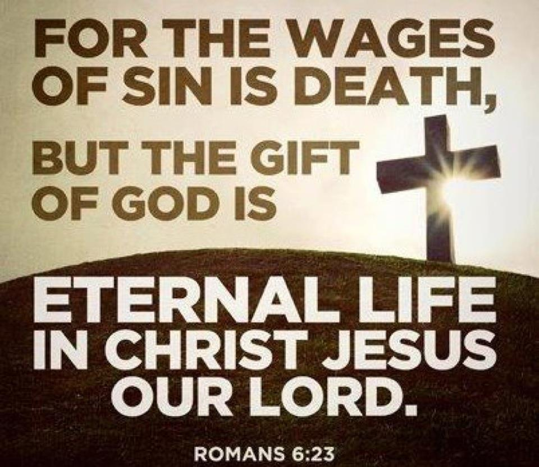
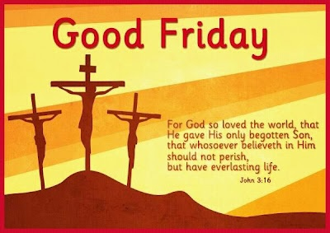

RESURRECTION
WHAT HAPPENED?  Following Jesus’ death, he is placed in the tomb of Joseph of Arimethea, as he had no tomb of his own. Also, it was nearing the Sabbath, and the body needed to be made safe very quickly.  - After the Sabbath, his women followers return to find that the tomb is empty. They are told that Jesus has returned to life. In Marks Gospel, a ‘man in white’ (who could be an angel or Jesus) tells them to return to Galilee. In John’s Gospel, it is the risen Jesus who tells Mary Magdalene about his resurrection, and tells her to tell the disciples what she has seen.  - Jesus makes several ‘resurrection appearances’ to his disciples. He appears to Cleopas on the road to Emmaus, and also to the disciple Thomas, who does not believe it is Jesus until he touches the wounds of the crucifixion.  - The stories stress that Jesus has physically resurrected – he is not a ghost, or a zombie. | ASCENSION  - Jesus’ ascension is the end of his life when he is taken into Heaven, with his spiritual body intact.  - It suggests that he rises up through the clouds until he is out of sight – many Christians believe this to be the case (historic truth)  - Others suggest that the ascension contains religious truths  - It symbolises the finality and end of Jesus’ mission, successfully completed  - It symbolises his divinity and his kingship
Key question: did Jesus come back to life?

ARGUMENTS FOR  The arguments against are unconvincing because:  - The women had already been to the tomb – they knew which one it was  - Jesus would not have been able to get out of the tomb when he was so badly injured.  - The disciples were mostly executed for spreading Christianity – most people would let themselves be killed for a made up story.  - The disciples behaviour changed as a result. Peter originally fled from the Romans after Jesus death, and denied that he knew him. However, only weeks later he was telling everyone about Jesus, even until he was crucified. If Jesus hadn’t really come back from the dead, why did Peter change so much? | ARGUMENTS AGAINST  Returning from the dead is impossible – it is far more likely that there is an explanation, for example:  - The tomb was empty because the women went to the wrong tomb  - Jesus was not actually dead when he was removed from the cross – he left the tomb on his own  - The disciples made up the story to gain prestige, or to create their own religion

SIN
- Sin is disobedience to God’s laws. It is not the same as breaking man made laws. Many man made laws are also sins e.g. murder, but some sins are legal e.g. adultery.  - The first human sin is found in the story of Adam and Eve in Genesis 3.  - Adam and Eve break Gods only rule, and eat forbidden fruit.  - Adam is punished with hard work, and Eve is punished with pain in childbirth, and now must be a servant to her husband.  - Both are evicted from the Garden of Eden  - Christians believe that sin of Adam and Eve passes from generation to generation, and that as we are all descended from Adam and Eve, that we carry the burden of this original sin. Because of Original Sin, we have a tendency to make poor moral choices, commit further sins, and harm others  - Humans cannot stop this without the help of God  - Christians who believe in the religious truth of the Genesis story will argue that it is symbolic of the natural disposition people have to perform wrong actions. These Christians might believe that salvation can be achieved without the help of God, through good actions alone. | Christian teachings about sin  - Genesis 3 introduces human sin. Eve is tempted by the serpent, who in turn tempts Adam to eat the forbidden fruit  - The Catechism of the Catholic Church teaches that original sin is passed on from generation to generation, but that humans can be saved through accepting Jesus as saviour  - In the Gospels, Jesus states ‘the only way to the Father is through me’, suggesting that the only way to enter Heaven is to accept Jesus as saviour to remove sin.

SALVATION AND ATONEMENT
Salvation through works  - Based on the Jewish idea that salvation was achieved by following the Jewish law  - Some Christians believe that by following God’s laws, they can earn a place in Heaven  - Others believe that it is not just about following the law, but also by having a pure heart and mind – good actions done purely for reward, and not with good intentions, are not worthy of reward.  - The important idea about salvation through works is that it means people can earn their place in Heaven through their own actions | Salvation through grace  - Grace is also referred to as God’s love, or God’s blessing  - Most Christians believe that without God’s grace, humans cannot be truly good.  - God’s love is best shown through his sacrifice of his son Jesus, to take away Original Sin, and allow people to lead moral lives  - While this gift is given to all people, they must be open to it, and accept it into their lives.  - God’s grace is made known to people through the Holy Spirit
Christian teachings about salvation
- In the Parable of the Prodigal Son, the son does not deserve the forgiveness of his father – he has not earned it. This suggests that salvation through works is a false idea. His salvation comes through his fathers love and forgiveness, in the same way that Christians believe their sins are forgiven because of God’s love and grace.
- St. Paul originally hunted and persecuted Christians. He had a religious experience on the road to Damascus, and then become a follower of Jesus, writing many letters (and a large part of the New Testament). He writes that he ‘does not deserve to be called an apostle, but by the grace of God, I am what I am’. Again, this suggests that Paul’s salvation was not through his own actions, but because God extended his grace to him.
- “God so loved the world, that he gave his one and only Son; that whoever believes in Him shall not perish, but have eternal life” – John 3:16. This quote explores the reason behind Jesus’ sacrifice, and also why it was necessary.
- In John’s Gospel, Jesus teaches that Christians should follow Jesus’ example, by submitting to the wishes of God
- The Catechism of the Catholic Church teaches that only through Jesus sacrifice, and God’s grace, can salvation be achieved

Role of Christ in Salvation
- The death of Jesus is key to God’s plan of salvation. It was a planned event that would allow for the forgiveness of original sin.
- Because sin was brought into the world by humans, it could only be removed by humans – this is why God becomes incarnate and is sacrificed on the cross
- Jesus takes on the sins of the world, and pays the debt of sin with his death. This gives humanity a fresh start and a chance for moral lives Jesus’ death repairs the broken relationship between humans and God that was caused by original sin. When humans sin, they separate themselves from God. Jesus’ death allowed for atonement (making amends for past mistakes), which was necessary as humans were not capable of doing this themselves
- Jesus’ death is also an act of reconciliation (repairing broken relationships). The relationship between humans and God was so damaged, only a drastic action like self sacrifice could repair it.

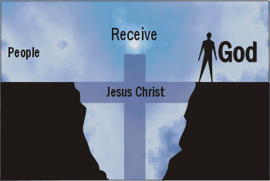
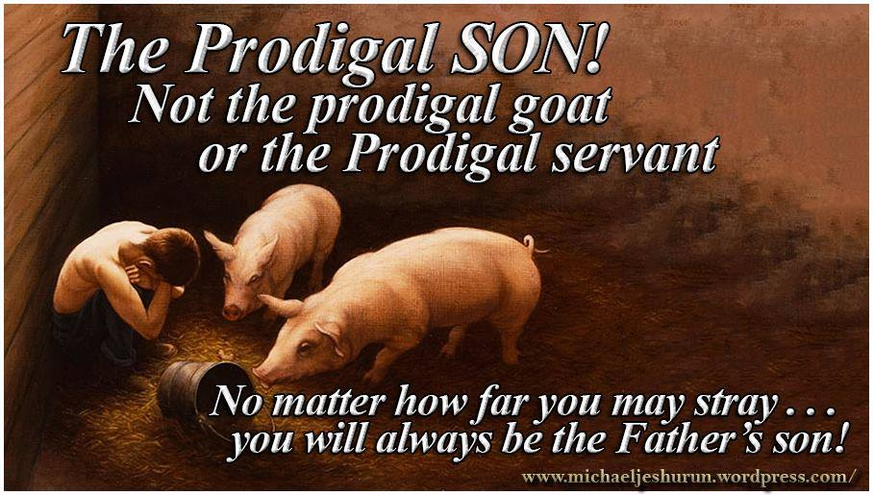
Practice questions

